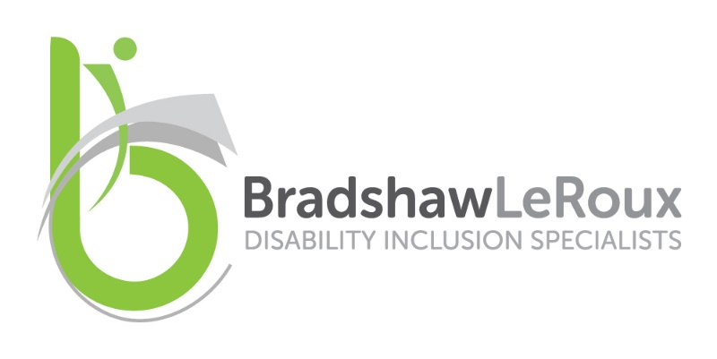

Season 2 - Episode 1 : From Whispered Worries to Real Conversations

Welcome to The Disability Advantage: learning to do business better from lived experience.
This is the show where we get real about leadership, disability, and how to turn good intentions into actual impact. I’m Lesa Bradshaw, international speaker, diversity and disability consultant, and empowerment champion.

I help organisations build disability confidence, which leads to big wins for your people and for your business. In this podcast, expect straight talk, humour, practical ideas and insights.

This is Season Two: From Intention to Impact.
We’re diving into stories, questions, interviews and concepts that help you move from thinking to doing. I hope you enjoy the episode, and if it sparks something for you, please share it with your network.

Host:
Hi Lesa. In today’s episode, we’re tackling the difficult questions hiring managers and leaders often have, but rarely say out loud. You’ve heard these queries whispered in private conversations for years, and you’ve always been clear that keeping them in the shadows doesn’t help anyone.

So today we’re bringing them out into the open, honestly, practically, and with the aim of helping everyone get this right.
Before we get into the toughest scenarios leaders face, we need to get the foundations right. Language sets the tone for everything that follows, so let’s begin there.
Different regions use terms like “persons with determination”, “handicapped” or “disabled person”. What terminology is appropriate, and why does it matter?

Lesa:
Thanks so much. I think that’s a great question, because it’s very often where people first get stuck when they start conversations about disability inclusion and begin the journey to becoming disability confident.

The important thing to realise is that there is no single, universally agreed term that everybody in the world is comfortable with. It really comes down to the community you’re in, the culture you’re in, and the individual you’re speaking to. Different people have different preferences.

I’ll share some of my reactions to certain terminology so you can understand the different perspectives.

When we talk about “people of determination”, I think that’s hysterical. I always say, “Well, have you met all people with disabilities? Are they all determined?” You can’t assign a personality characteristic to an entire demographic who only really have one thing in common: an impairment that puts them at a disabling disadvantage.

We need to be very careful about using euphemisms that make the word disability seem like a dirty word.

The most commonly agreed approach, and the one I prefer, is person-first terminology. I prefer being called a person with a disability. I’m also a person with red hair, a person who owns a business. It’s just one part of my autobiography.

Other people prefer disabled person because they feel disabled by the barriers of everyday life and the inaccessibility of the world around them.

As a general rule of thumb, in Europe and the UK, disabled person tends to be the most commonly accepted term. Start there. If someone prefers something else, follow their lead.

In many other regions, person with a disability is a good starting point. It’s also useful when talking about different types of disability: a person with epilepsy, a person with a hearing impairment, a person with a mobility impairment, a wheelchair user. It reflects that disability is one part of who someone is, not the sum total.

My main takeaway is this: ask people what they prefer when you’re speaking one-to-one. Take their lead. If you’re speaking generally, people with disabilities or disabled persons are widely accepted terms.

Host:
Many leaders still fear that hiring a disabled candidate may impact performance. You’ve heard this before. How do you respond?

Lesa:
That’s such a common concern, the dreaded performance stigma. It comes from focusing entirely on disability rather than ability.
We’re so worried about what a person with a disability can’t do, we stop looking at what they can do. That knee-jerk reaction often starts with, “Do we want someone with a disability?” Instead, the question should be, “What can this person do, and how do they do it?”

Two people can have the same impairment and be disabled in completely different ways depending on their circumstances, support systems, assistive technology and environment.

Rather than making assumptions, assume capability. Ask open questions such as, “If you need any assistance, or if there’s anything I should know, let me know. I’m here to learn with you.”

If performance is a genuine concern, frame the question around the role. For example:
“This job is highly customer-facing, and you’ll deal with frustrated clients. I notice you have a stutter. How do you manage that in high-pressure situations?”

You’re not assuming incapability. You’re exploring how they overcome barriers to perform effectively.Once you have the facts, assumptions fall away. You don’t need to be an expert in everyone’s disability. That’s where the fear begins to ease.

Host:
Reasonable accommodation is used often but understood poorly. What does it actually mean in practice?

Lesa:
It’s a bit of an archaic term, and we’re moving more towards workplace adjustments. Who decides what’s “reasonable”, and why do they get that power?

In reality, we adjust workplaces all the time. Flexible hours for parents, hybrid working, ergonomic chairs. These are all workplace adjustments.

For disability, it simply means identifying the barrier that’s preventing someone from doing their job in a particular way or environment, and removing it.

We haven’t built our economy or world to be accessible for everyone, so we need to be proactive in removing disabling barriers. That’s all reasonable accommodation really is.

Host:
What if a requested adjustment genuinely can’t be provided?

Lesa:
Sometimes, despite best efforts, it truly can’t be done. But you must explore every option creatively.
Before COVID, remote work was often dismissed as impossible. Within two months, the entire world proved it was not only possible, but scalable.
Often the issue isn’t reasonableness. It’s perceived return on investment.

If you’ve explored every option and it still won’t enable performance, you can be honest about that. But then you must take what you’ve learned and stop recreating those barriers in future decisions.

Over time, those changes make the world more accessible for everyone.

Host:
If a candidate discloses a non-visible disability in an interview, what can a manager ask, and what should they avoid?

Lesa:
Focus on purpose. The interview is about suitability and ability, not personal history.
Personal questions like “How did that happen?” or “That must be awful” are irrelevant. Functional impact is relevant.

If safety is a concern, it’s appropriate to ask how the disability affects the role and what mitigations are needed. Keep it job-specific and practical.
That approach respects dignity while allowing informed decisions.

Host:
What about visible disabilities? Is it okay to ask what happened or call someone brave?

Lesa:
This is very personal. I’m a wheelchair user, and people often call me inspiring for doing everyday things like shopping. While intention matters, it often reflects low expectations.

Until you know someone’s preferences, treat them as you would anyone else. Context matters. Professional environments require professionalism.

Assume competence. Ask when needed. Be honest if communication needs adjusting. And if you get it wrong, apologise, learn, and move on.
Please don’t make decisions for people with disabilities. We know what’s best for us.

Host:
Some managers worry that adjustments for one or two people take too much time. How do you explain the return on investment?

Lesa:
Around fifteen per cent of the global population lives with a disability. That represents a vast talent pool and an equally significant consumer market. Yet many organisations still design products, services and workplaces as if that population barely exists.

People with disabilities develop exceptional problem-solving skills simply by navigating a world that was not designed with them in mind. They are constantly adapting, finding workarounds and thinking creatively. When organisations learn directly from lived experience, they don’t just create solutions for one group, they design better, more intuitive services that work for everyone.

Accessibility is no longer optional. It is now a legal, commercial and competitive issue. The European Accessibility Act, which is being implemented across the EU, sets mandatory accessibility requirements for a wide range of products and services, including digital platforms, banking, e-commerce, transport and customer service technologies. This legislation makes it clear that accessibility is not a “nice to have”, it is a regulatory expectation. Organisations that ignore it risk legal exposure, reputational damage and being locked out of major markets.

Disability-confident organisations consistently outperform others because they have learned how to be flexible and adaptable at scale. They design with inclusion in mind from the outset rather than retrofitting later. That mindset leads to stronger innovation, better customer experiences and more resilient business models.

This isn’t about accommodating one person as a special case. It’s about learning how to do business differently and better, in a way that meets legal obligations, strengthens competitiveness and delivers value for everyone.
Host:
As a final thought, what advice would you give managers who still have burning questions?

Lesa:
You’re not alone, and you don’t have to be perfect. Learn from others, share experiences, and be curious.

This isn’t just HR or compliance. It’s a competitive advantage.

Don’t be so afraid of getting it wrong that you don’t start getting it right. Ask questions. Learn as you go. Remove barriers where you can.
Small changes create ripples. Ripples create waves. And waves change the world.

Host:
Lesa, thank you so much for sharing these difficult questions and answering them so thoughtfully. I hope this conversation helps people move into true disability confidence.

Thank you.

